EXPERIMENT-9

DATA LINK LAYER TRAFFIC SIMULATION USING PACKET TRACER ANALYSIS OF CSMA/CD & CSMA/CA
Aim:To implement Data Link Layer Traffic Simulation using Packet Tracer Analysis
of CSMA/CD & CSMA/CA.
Software / Apparatus required: Packet Tracer / End devices, Switches,
connectors.
Requirements:
1. End device - They are the devices through which we can pass message from one device
to another and they are interconnected.
2 Switch/Hub - Interface Between two devices.
3. Cable - Used to connect two devices
Procedure:
STEP 1: Click on end devices, select generic Pc’s drag and drop it on the
window. Click on SWITCH drag and drop it on the window.
STEP 2: Select the straight through cable and connect all end device to switch. Assign the IP
address for all end devices. (Double click the end device Select →
desktop → IP configuration static)
STEP 3: Now set the IP address to Host A (192.168.1.1) in static mode. Similarly set IP address
for Host B (192.168.1.2) and Host C (192.168.1.3)
STEP 4: To view the IP address, give ip config command in command prompt. Using ping
command, we can establish communication between two host devices.
STEP 5: Now display the packet transmission in simulation mode.

Output:

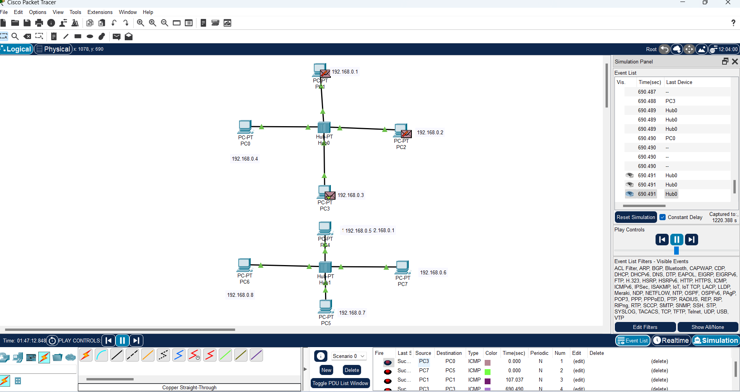

Result: Thus Data Link Layer Traffic Simulation using Packet Tracer Analysis
of CSMA/CD & CSMA/CA is implemented successfully

